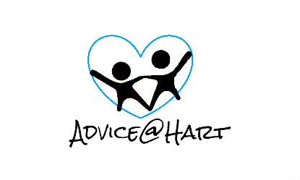

Our safeguarding policy
This policy applies to all staff, including senior managers and the board of Directors, paid staff, volunteers/ sessional workers, agency staff, students or anyone working on behalf of ADVICE AT HART CIC.
The purpose of this policy is:
• To protect children, young people and adults who receive ADVICE AT HART CIC services. This includes the children of adults who use our services;
• To provide staff and volunteers with the overarching principles that guide our approach to safeguarding ADVICE AT HART CIC believes that a child, young person or adult should never have to experience abuse of any kind. We have a responsibility to promote the welfare of all children, young people and adults and to keep them safe. We are committed to practice in a way that protects them.
Legal Framework This policy has been drawn up on the basis of law and guidance that seeks to protect children, namely:
• Children Act 1989
• United Convention of the Right of the Child 1991
• Data Protection Act 1998
• Sexual Offences Act 2003
• Children Act 2004
• Protection of Freedoms Act 2012
Relevant Government guidance on safeguarding children
We recognise that:
• The Welfare of the child is paramount, as displayed in the Children Act 1989
•Some children are especially vulnerable due to the imp act of previous experiences, their level of dependency, their communication needs or other issues
• All children regardless of their age, disability, gender, race, religious beliefs, sexual orientation or identity, have the right to equal protection from harm
• Working in partnership with young people, their parents, vulnerable adults, carers and other agencies is essential in promoting the welfare of those we need to protect.
We will aim to keep children safe by:
• Valuing them, listening to them and respecting them as individuals
• Implementing thorough procedures and a code of practice for staff and volunteers which adopts child protection best practices
• Developing and implementing an effective e-safety policy
• Providing effective management for all staff and volunteers through supervision, support and training
• Recruiting staff and volunteers using safer recruitment best practice, ensuring all necessary checks are completed
• Sharing information about child protection and good practice with children, parents, staff and volunteers
• Sharing concerns with relevant agencies and involving parents and children appropriately
• Informing all visitors of ADVICE AT HART CIC of policies and safeguarding expectations

Name - Clair Gilbraith Position - Director
REVIEWED & REVISED: 30THJuly 2021

NEXT REVIEW: 30th July 2022

